Horror Movie Blogsite - Fernanda’s Recs

Project Basics Answered
- What do you want to build?
  - Transform my 3 horror movie recommendation blog posts into a website with all of my recommendations. I want it to have filters to be able to find movies faster like zombie movies, or international movies. I want to include the IMDb and rotten tomato scores for each movie (if possible, if API is free, or whoever it works). I want it to have a section about me with a little background about why I love horror movies. I would love it if this became a website people consult to get good horror movie recommendations.
  - Links to my horror movie recommendation blog posts:
    - https://sinsognar.wordpress.com/2025/03/12/scary-movies-you-have-to-watch/
    - https://sinsognar.wordpress.com/2020/10/29/10-peliculas-de-terror-para-asustarse/ (in spanish should be translated to english)
    - https://sinsognar.wordpress.com/2017/06/30/las-mejores-peliculas-de-miedo-segun-fer/ (in spanish should be translated to english)
- What should it look like?
  - A simple homepage with icons that opens the review for each movie. Homepage should have filters to categorize movies by theme. A different page with information about me. Minimalist design that also has a horror vibe, shouldnt be the typical earth toned website. Can be colorful. Easy to navigate.
- Who will be using it?
  - People searching for which horror movie to watch. Horror movie fans that want to read more opinions about the movies they have watched. For myself! A personal repository of the movies I’ve watched and liked the most.
- What is it’s main purpose?
  - Firstly, show off that I can use AI to create a very cool website. Second, to have a creative output of my love for horror movies. Third, to become a website people consult regularly when looking for good recommendations of horror movies.
- What must it not do or include?
  - It is not just a long list of all movies.
  - It is not a traditional blog style
- What features should be present?
  - Home page with all horror movie recommendations, but you have to click each one to read more about it. This home page could be in the way a desktop works, a space with desktop icons, each icon with the title of movie, once clicked it opens the whole review.
  - Each review page should have ideally IMDb and rotten tomatoes score (if free to add the API), otherwise no outside rating. Movie name, image still from the movie, body text with my review, tags of the movie to be able to filter on the home page (for example supernatural movie, international, etc).
  - About me page. An image that represents me (not sure if I want my face on it?), body text with a my backstory of why I love horror movies. A section about why I decided to create the website. A contact form to get in touch with me.
- How should it work, and how will you know when it’s working the way you want?
  - A user should be able to see the whole homepage, scroll through it, click any icon and see the review of the movie, go back to the home page, be able to filter movies based on themes, navigate to the about me page, and be able to fill out the form that sends me an email.
  - I will know its working once I send it to friends and family and they are able to navigate without problems on desktop and mobile.

The Vibes
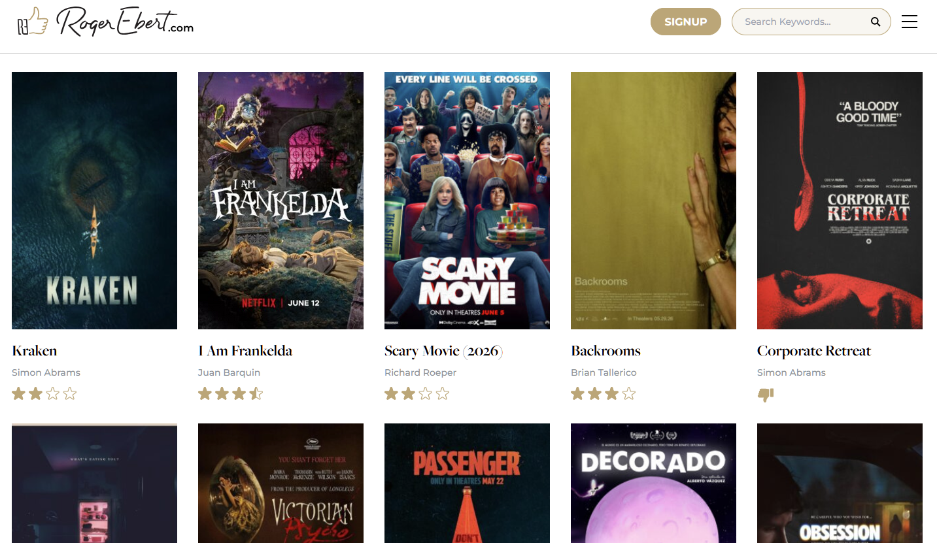
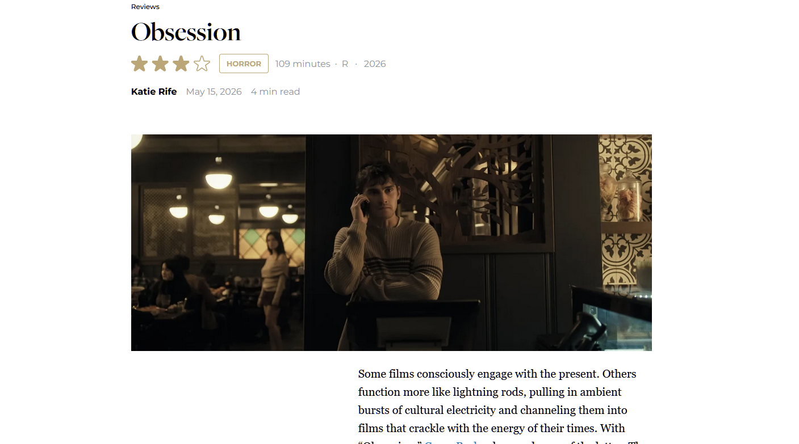
- https://www.rogerebert.com/collections/horror-movies - from this site I like that the homepage uses my icons idea, just a collection of movie posters with their name and director. Once clicking on a poster it takes you to the movie review. I like that it lists at the top the length of the movie, the rating, and the year. Then one still image from the movie and then the body text with the whole review.

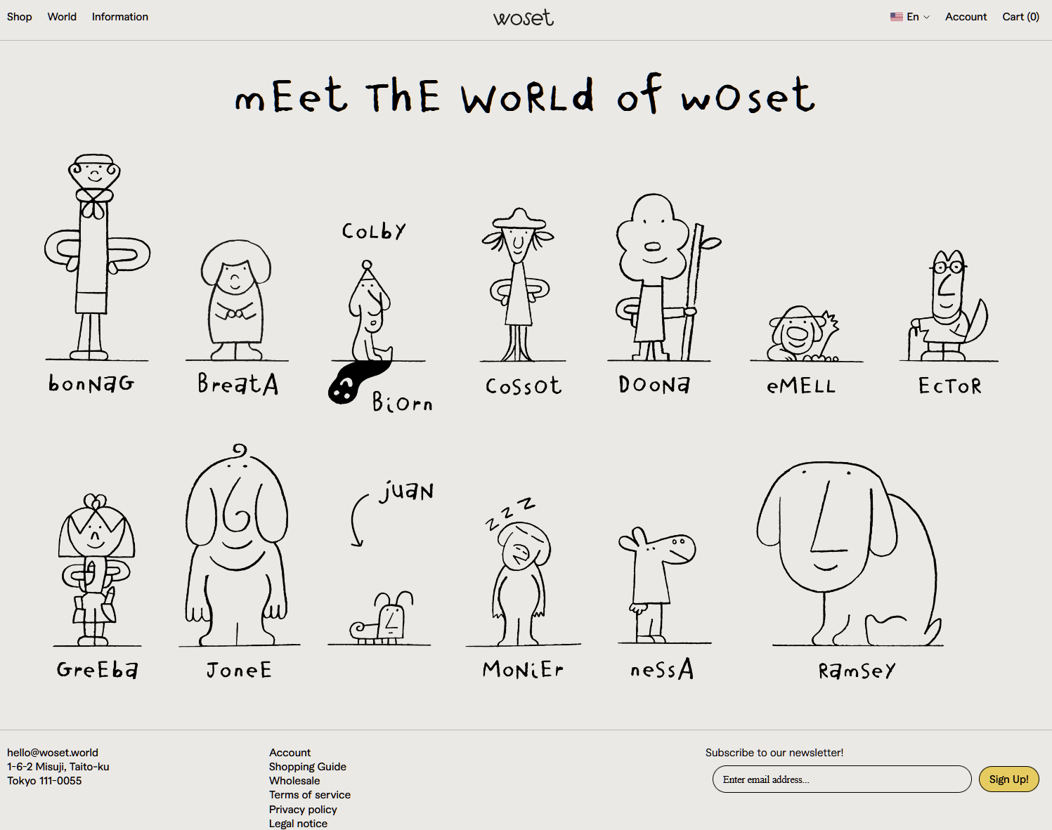
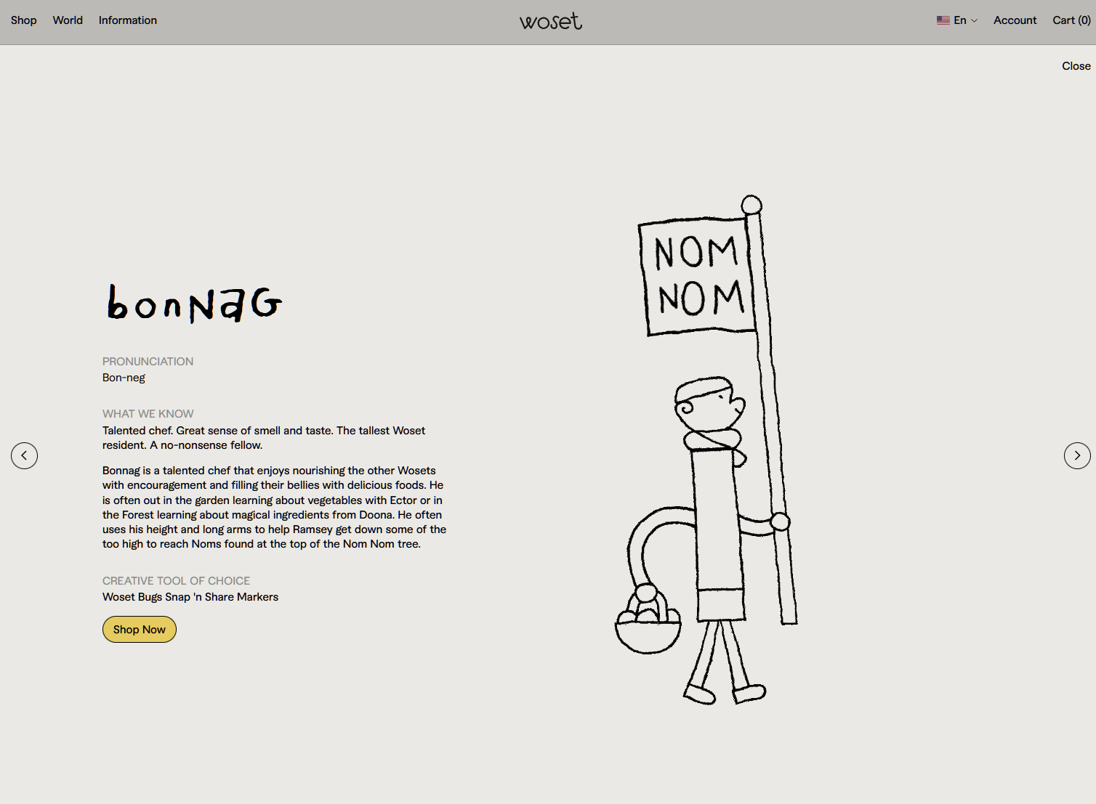

- https://woset.world/pages/world - this home page is the design idea I had in my head, simple icons on a simple background. Each icon with its name. When clicked, it slides up full info about the product, which in my case would be the movie info and review. I really like this animation, and flow. I want my homepage and each movie’s page to work like this.

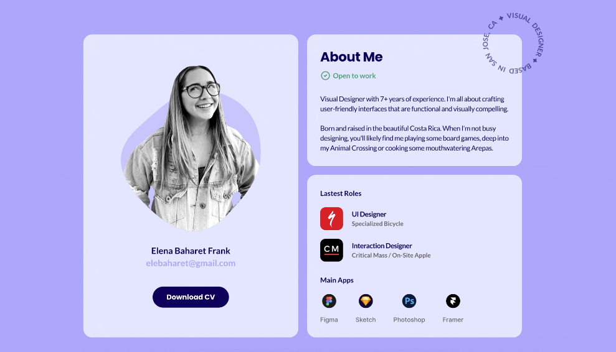
- I like this screenshot of a portfolio about me page. Colorful background, with three boxes of information. First box with picture or representation of person, name and button to contact. Second box with the About Me information - here I would put a little about myself, not necessarily all movie related. Third box has roles and apps she uses, for me I would use this space to talk about why I love horror movies, maybe my current top 3 favorite movies.

